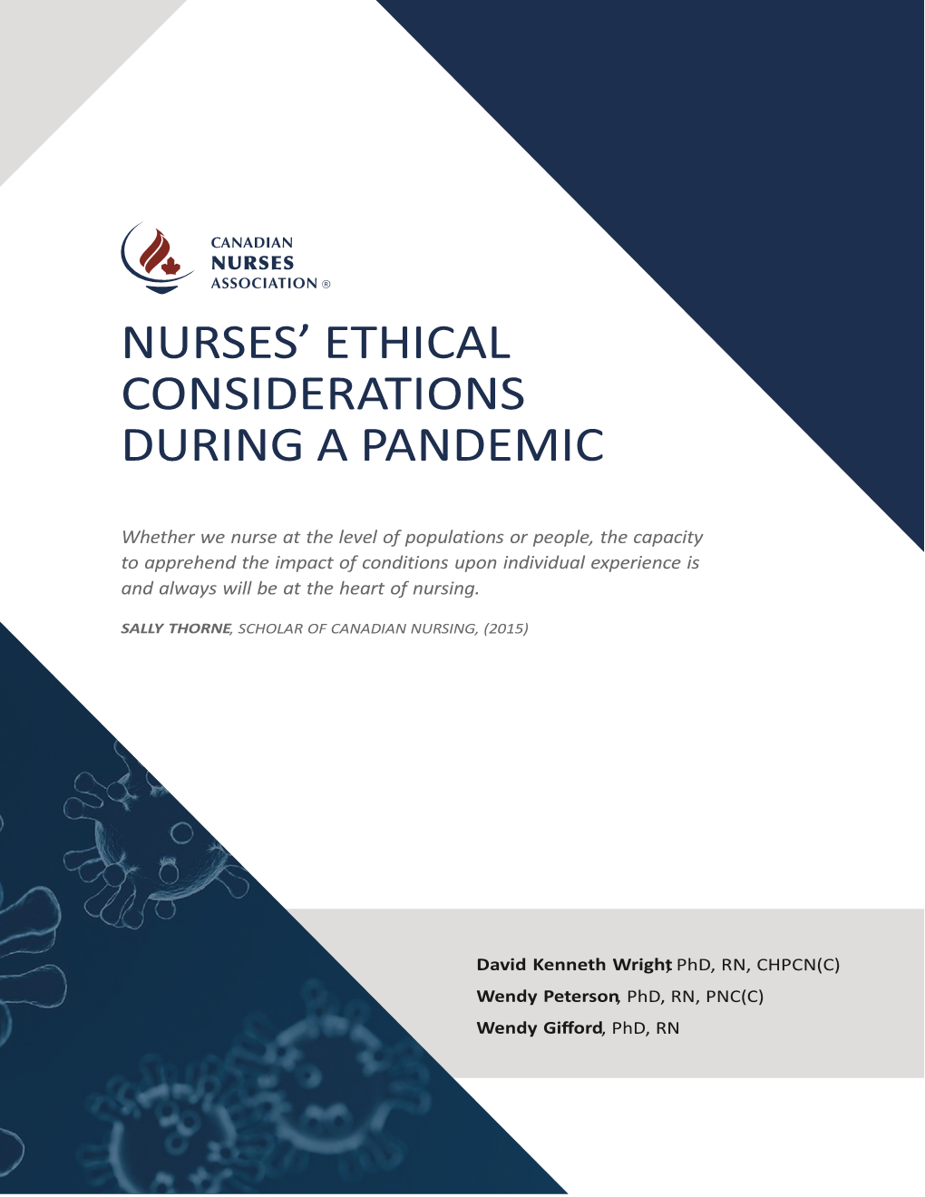

How can we honour the
dignity of persons receiving care?

BY RAISING OUR VOICES
The CNA Code of Ethics establishes dignity as a primary nursing value. The cases at the beginning of this paper show how dignity can be undermined in a pandemic situation. For example, in the case of John, who was working in long-term care, the neglect of frail residents who are unable to accomplish their own activities of daily living without assistance is an affront to their dignity. Importantly, this case highlights a caregiving situation that was already precarious, where staffing was inadequate even before the pandemic began. As mentioned above, while a pandemic introduces many new ethical challenges for nursing, it also unveils longstanding systemic issues that predate it (Tomlinson & Robertson, 2020). Nurses and nursing students are acutely aware of such issues and have been sounding the alarm while others turn a deaf ear. Indeed, while nurses and nursing students are the primary whistleblowers in health care, too often they face negative consequences for speaking up about ethical issues in their practice (Gagnon & Perron, 2019). This potential for negative reprisal has a silencing effect on nurses' voices. And yet, the final report of Ontario's SARS commission is clear: ethical practice is supported when health system administrators and governments listen to - and act on - the concerns raised by nurses, other care providers, and the unions that represent them (Campbell, 2006). Nurses' voices are an essential resource in preventing and mitigating the harms a pandemic will cause to the dignity of people receiving care.

Although nurses are sometimes lauded for their heroism in situations of health crisis, they are also excluded from decision-making at various levels (from direct-care through to health systems planning) (Austin, 2008). Nurses are not heroes; they are skilled professionals whose knowledge is crucial at all levels of a pandemic response. Individual nurses therefore need to be encouraged and supported to speak up when they become aware of ethical issues in their practice, such as the situation described in John's case. Vulnerable people, such as residents in long-term care, do not lose their right to be treated with dignity and respect, even in pandemic circumstances. In all situations, and especially during a pandemic, it is essential that health-care environments encourage nurses to use their voice. Such an environment "sponsors openness, encourages the act of questioning the status quo and supports those who speak out in good faith to address concerns" (CNA, 2017, p. 16).

During the COVID-19 pandemic, some nurses are speaking out through the media (e.g., Greenaway, 2020). Nurses must not be made to fear using their voice in this way. Because nursing is one of society's most trusted professions, nursing administrators, regulators, and professional associations all share the responsibility to support nurses in speaking the truth about what is happening at the forefront of a pandemic response.

Canadian Nurses Association – Nurses Ethical Considerations During a Pandemic – page 8

