Testimony Evidence for PowerPoint Presentation
Slide 10 – Prime Minister’s Vaccine Announcement
Prime Minister announces mandatory vaccination for the federal workforce and federally regulated transportation sectors | Prime Minister of Canada (pm.gc.ca)
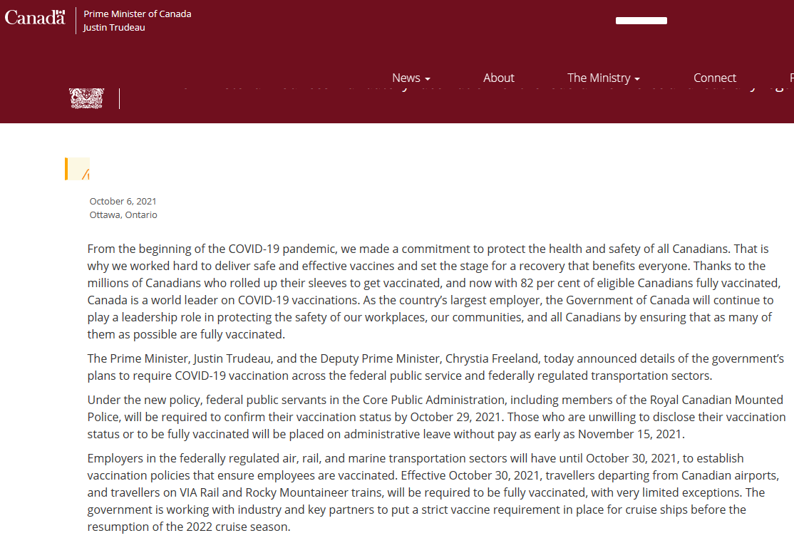
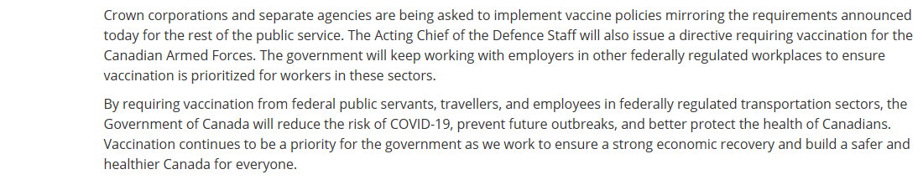

Slide 13 – Canada Labour Code: Duties of Employer
Canada Labour Code (justice.gc.ca)
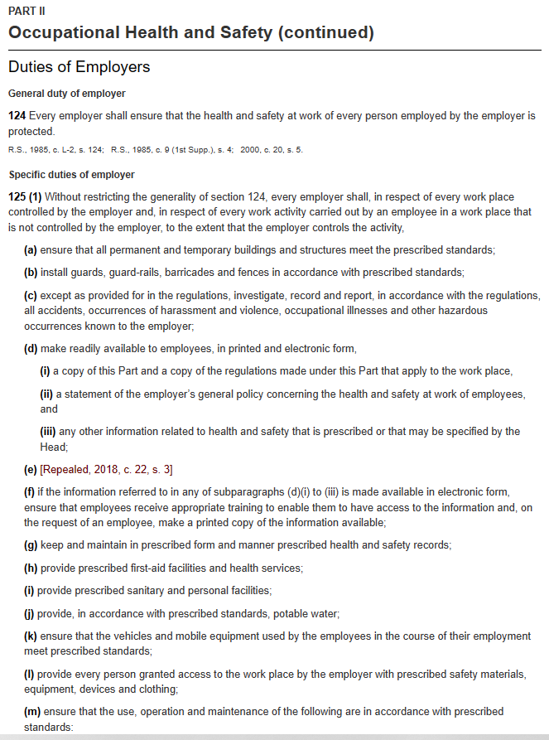

Slide 16 – Criminal Code of Canada: Section 217.1 & 219
Criminal Code (justice.gc.ca)
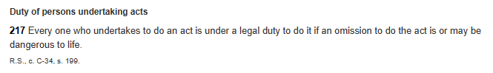
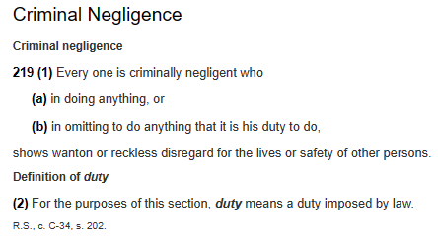
Slide 16 - Westray Law
Criminal liability for workplace deaths and injuries – Background on the Westray Law (justice.gc.ca)
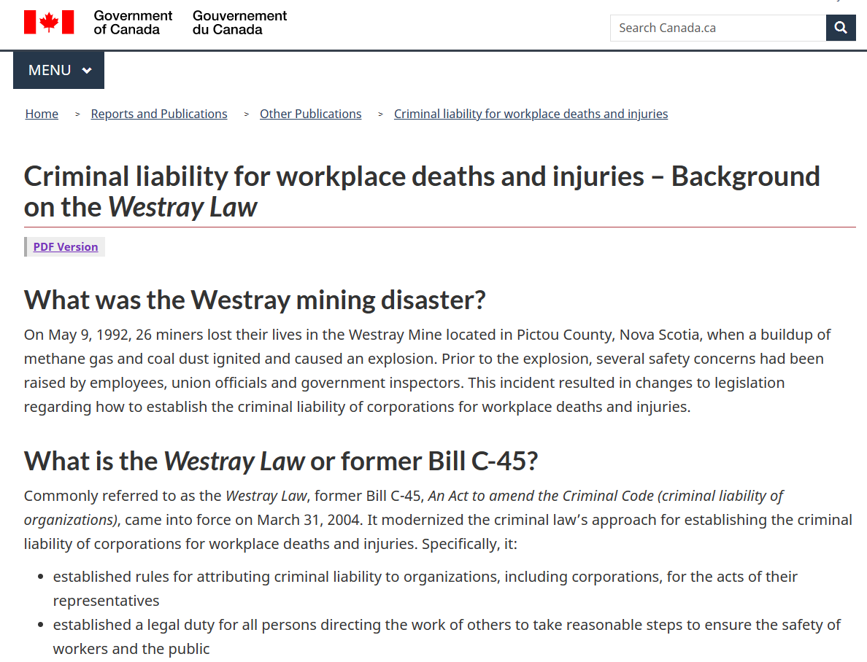

Slide 17 – The Right to Know, The Right to Refuse: Canada Labour Code
Occupational health and safety in federally regulated workplaces - Canada.ca
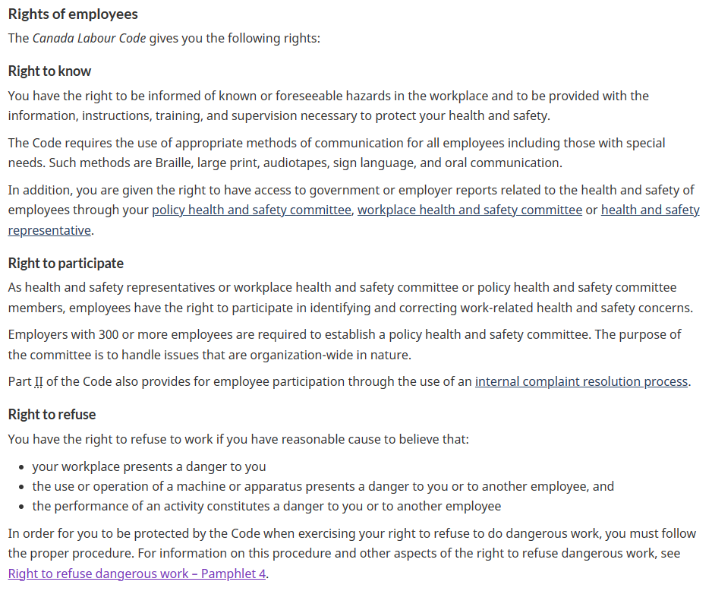
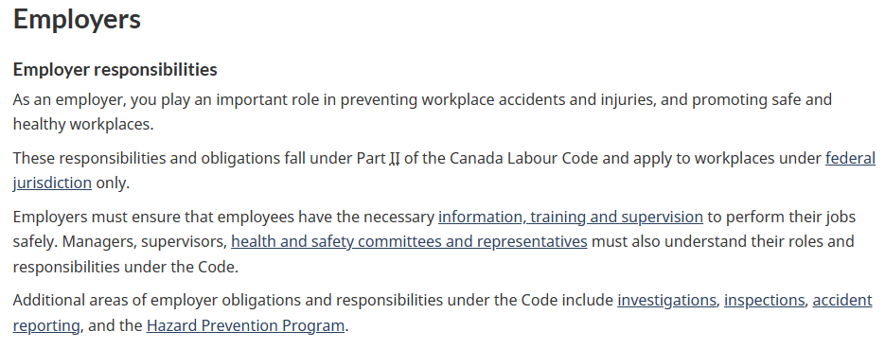

Slide 17 – Definition of Danger – Interpretative Guidelines
Definition of Danger - 905-1-IPG-062 - Canada.ca
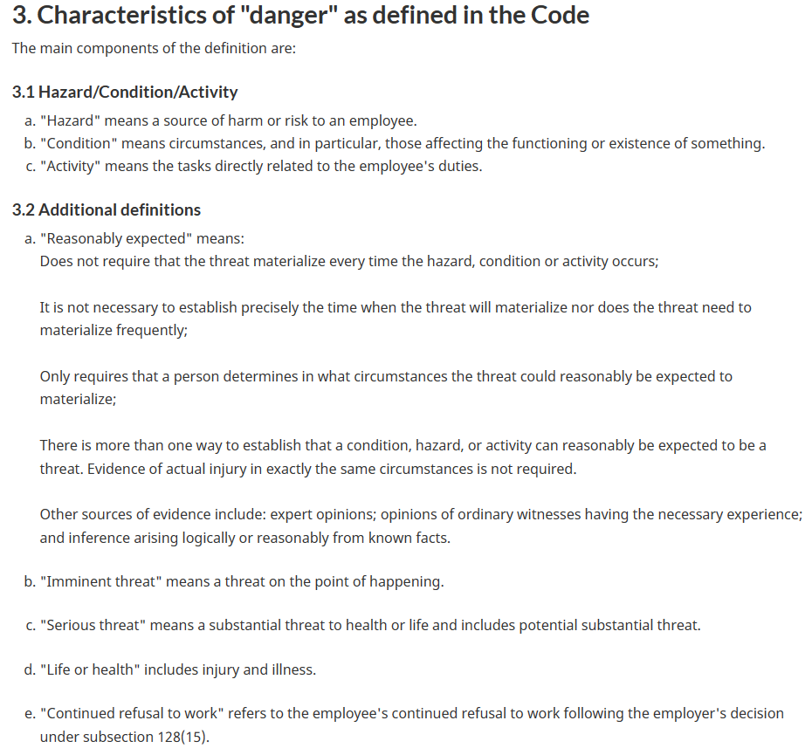

Slide 18 – Hazardous Products Act – Government of Canada
Hazardous Products Act (justice.gc.ca)
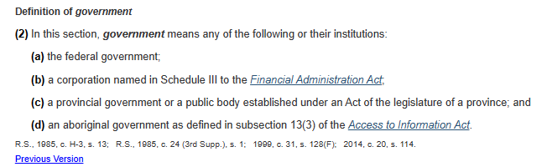
Slide 18 – Dangerous Goods/WHMIS – Canada Labour Code Further Specific Duties of Employer
Canada Labour Code (justice.gc.ca)
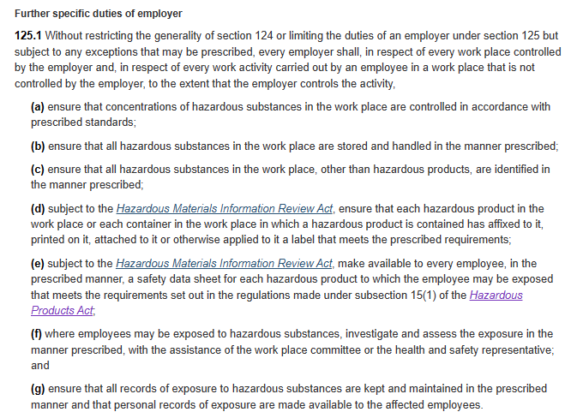

Slide 18 – Canadian Occupational Health and Safety Regulations: Part 10 Hazardous Substances
Canada Occupational Health and Safety Regulations (justice.gc.ca)
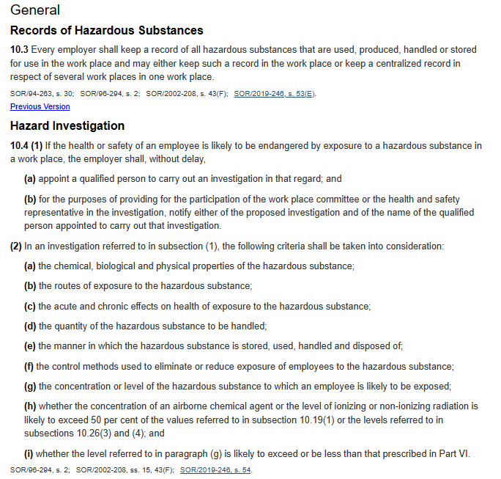
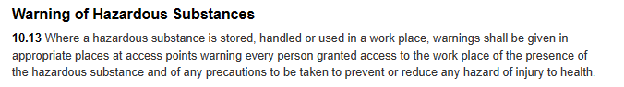

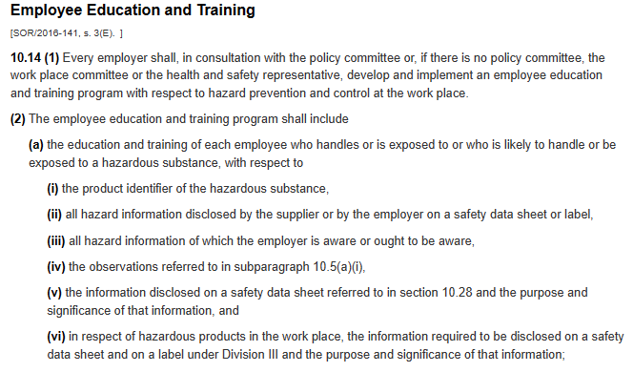
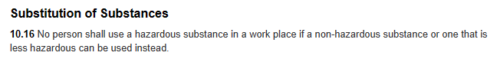

Slide 18 WHMIS – Government of Canada
Roles and responsibilities under WHMIS - Canada.ca
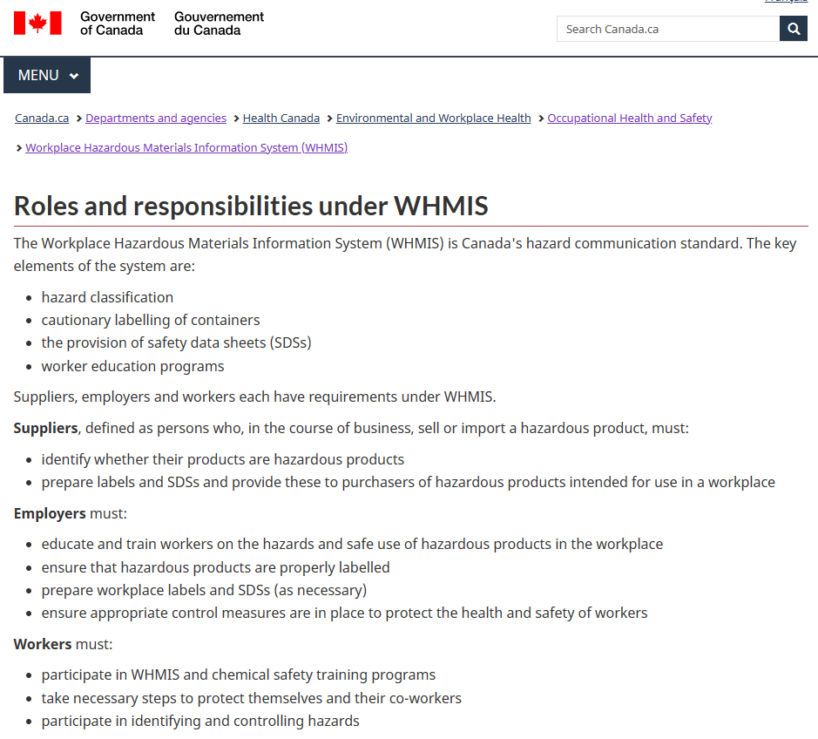

Slide 19 – Genetic Non-Discrimination Act – PCR Testing
Genetic Non-Discrimination Act (justice.gc.ca)
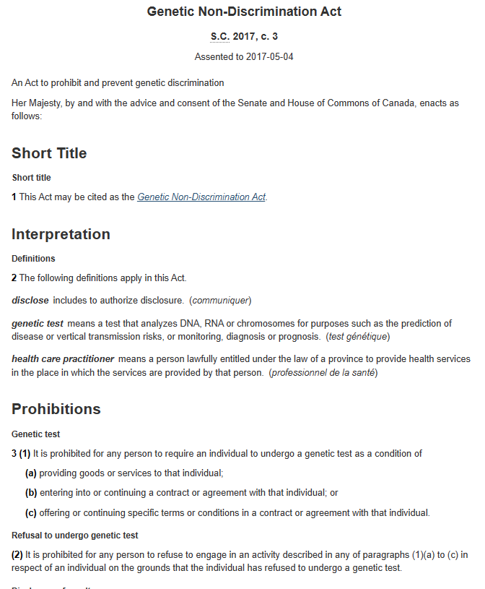

Slide 19 – Assisted Human Reproduction Act – DNA Manipulation
Assisted Human Reproduction Act (justice.gc.ca)
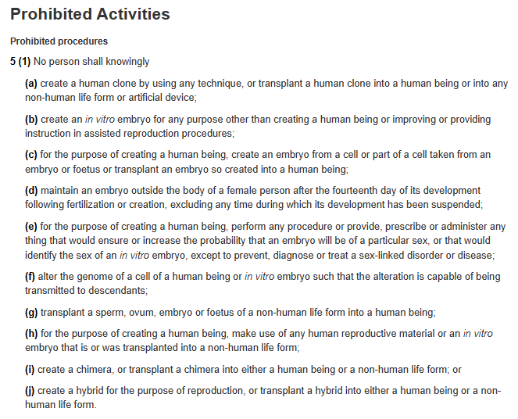

Slide 20 – Collective Agreements – Canadian Union of Postal Workers: Article 33
urban-ja-31-2018-ca-web-en.pdf (cupw.ca)
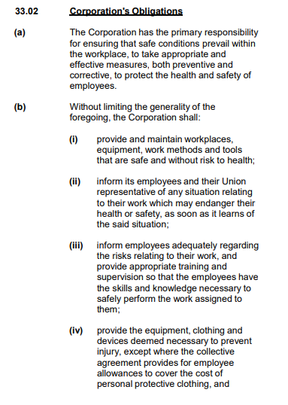

Slide 24 – Workers Compensation Board examples of employer liability for vaccine injury
British Columbia
COVID-19 vaccination and the workplace - WorkSafeBC
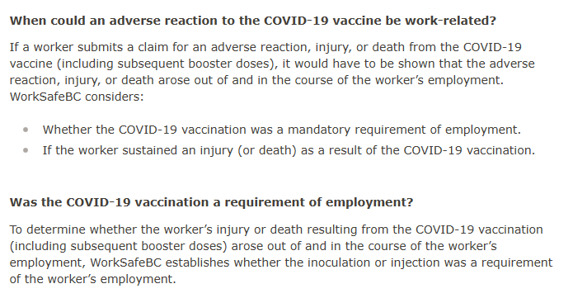
Saskatchewan – Workers Compensation Board
Frequently asked questions for employers on COVID-19 | Saskatchewan Workers' Compensation Board (wcbsask.com)
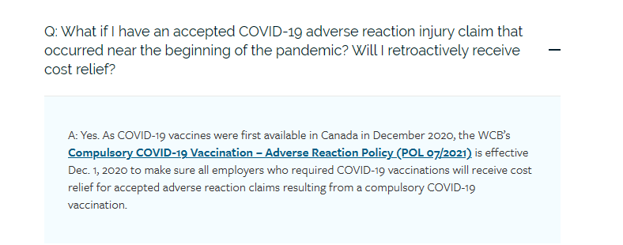

Manitoba – Workers Compensation Board
How the WCB is Responding to COVID-19 | Workers Compensation Board of Manitoba
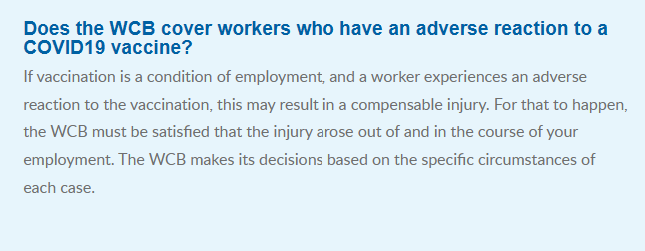
Ontario – Workers Compensation Board
COVID-19 vaccinations | WSIB
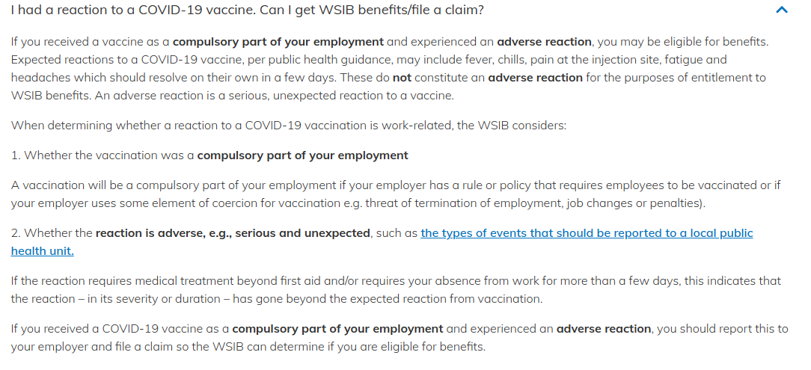
Nova Scotia – Workers Compensation Board
COVID-19 (wcb.ns.ca)
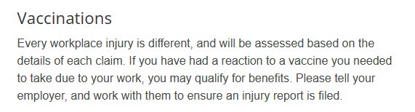

Slide 25 – Canadian Occupational Health and Safety Regs Part 12: Protection Equipment and Other Preventative Measures
Canada Occupational Health and Safety Regulations (justice.gc.ca)
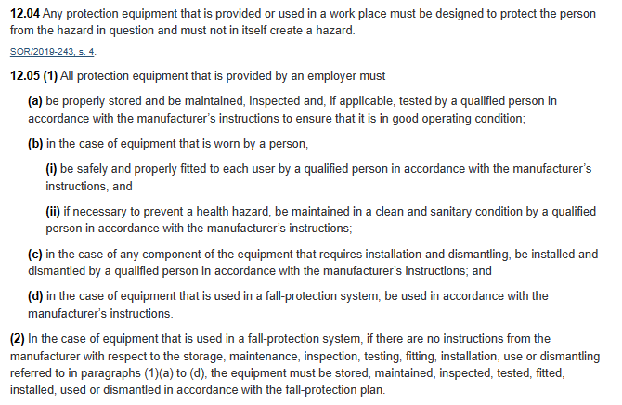
Respiratory Protection 12.13
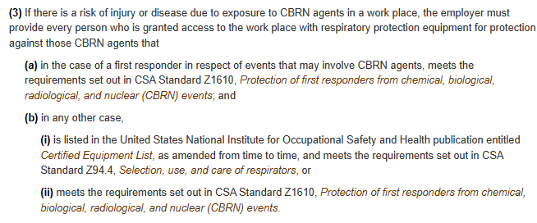

Slide 27 – Safety Data Sheet – ALC-0315 Cayman Chemical – Article number 34337
ALC-0315 (CAS Number: 2036272-55-4) | Cayman Chemical
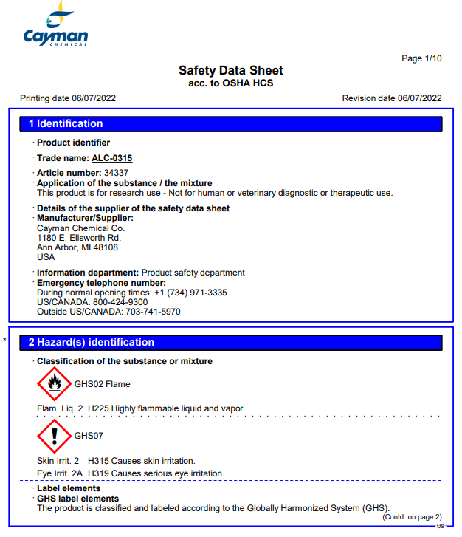

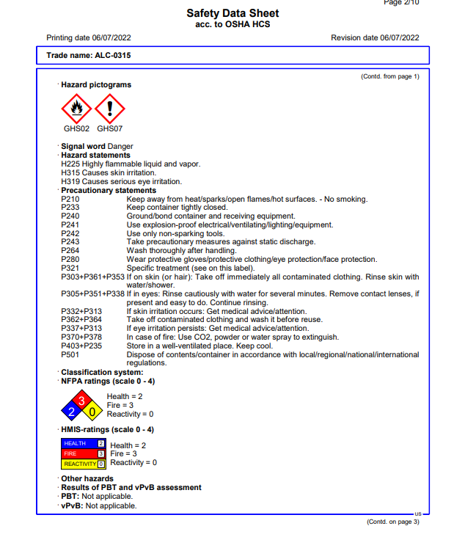

Slide 27 – Safety Data Sheet – ALC-0159 Cayman Chemical – Article number 34337
ALC-0159 (CAS Number: 1849616-42-7) | Cayman Chemical
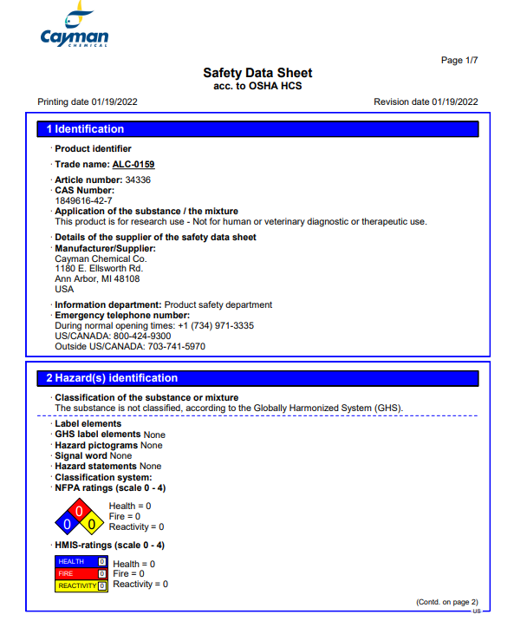

Slide 27 – Safety Data Sheet –SM-102 Cayman Chemical – Article number 33474
SM-102 (Lipid H, LNP-102, CAS Number: 2089251-47-6) | Cayman Chemical
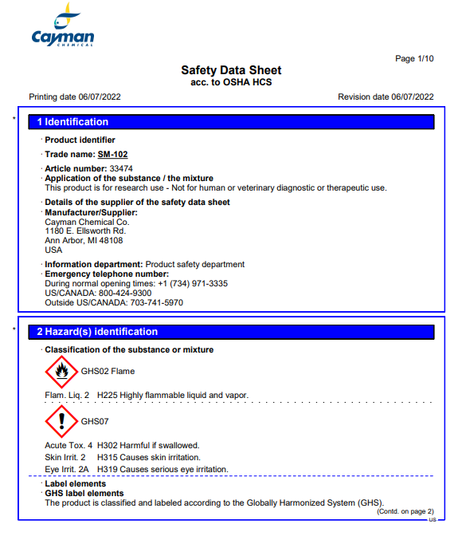

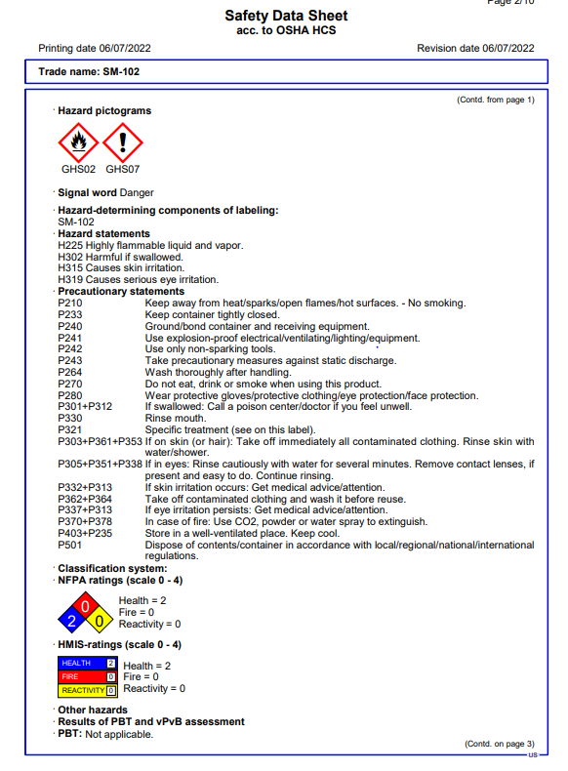
Slide 27 – Health Canada Vaccine Ingredients Pfizer: ALC-0159 & ALC-0315
Pfizer-BioNTech Comirnaty COVID-19 vaccine - Canada.ca
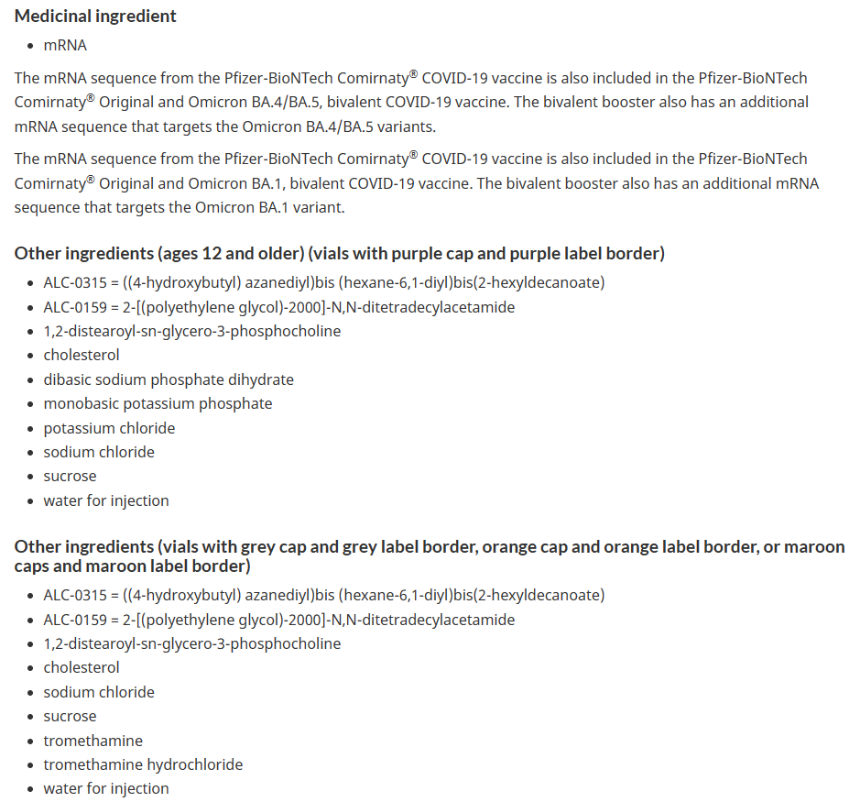

Slide 27 – Health Canada Vaccine Ingredients Moderna: SM-102
Moderna Spikevax COVID-19 vaccine - Canada.ca
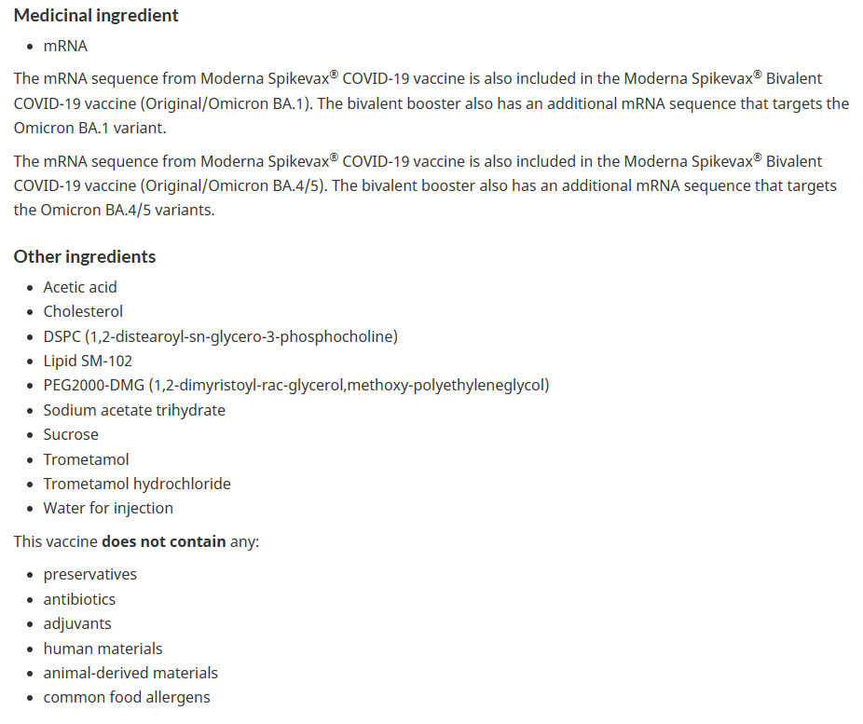

Slide 30 – SALK Institute study warning of the health deaths due to the spike protein
The novel coronavirus’ spike protein plays additional key role in illness - Salk Institute for Biological Studies
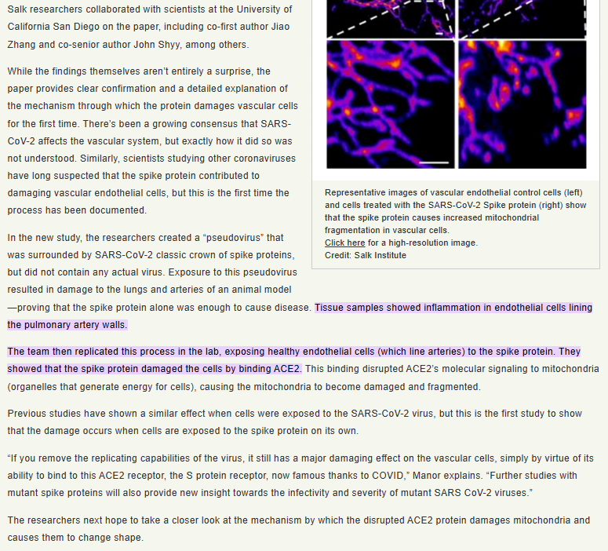

Slide 31 – VigiAccess Covid-19 Vaccine Adverse Events Statistics
VigiAccess
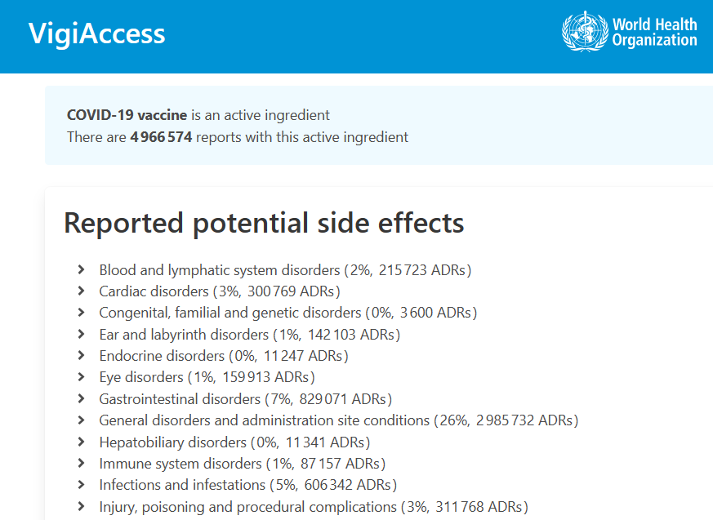

Slide 32 – Labour Board Rulings of No Danger in 2020 – prior to vaccines
Sudbury Ontario Decision
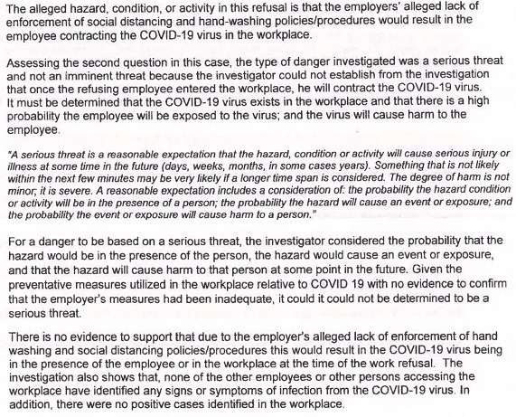
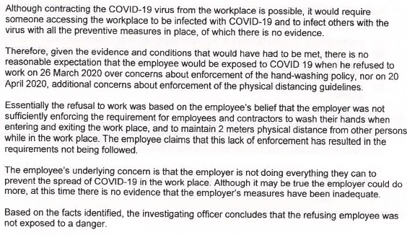

Slide 32 – Labour Board Rulings of No Danger in 2020 – prior to vaccines
Mississauga Ontario Decision
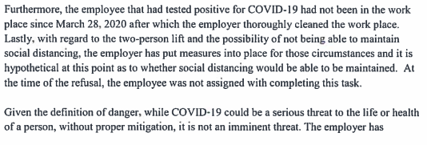
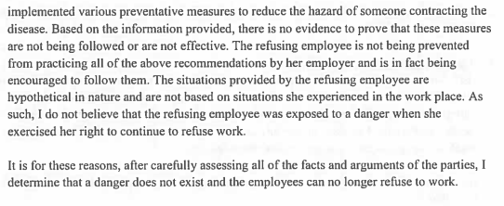

Slide 33 – Employee Right to Refuse Dangerous Work – Canada Labour Code
Canada Labour Code (justice.gc.ca)
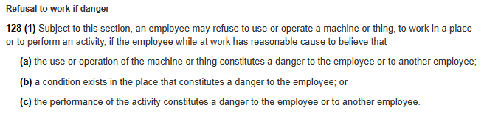
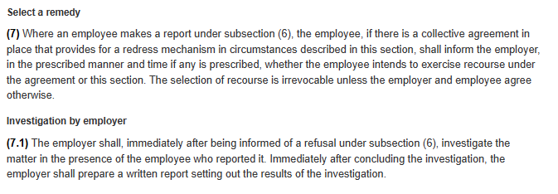
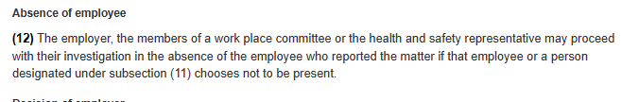
Slide 34 – Manager’s Handbook Canada Labour Code Part II – Government of Canada
Manager's Handbook Canada Labour Code - Part II - Canada.ca
